**MTS160D**

**Magnetic Track Sensor with Position and Angle Reporting**

# Product Overview

## Description

The MTS160D is a cutting-edge magnetic guide sensor designed specifically for mobile robots, offering precise tracking and position measurement capabilities. It is uniquely distinguished by its patented technology for detecting and measuring the angular position of a magnetic track along the horizontal axis. This feature allows the robot to follow its designated paths with higher precision, and to navigate bends at increased speeds without compromising on accuracy or safety.

The MTS160D can serve as the sole guidance sensor in robots that follow fixed paths, offering the lowest cost solution without sacrificing precision or reliability. Alternatively, for robotic systems equipped with laser or vision navigation systems, the MTS160D can be integrated as an additional component to achieve last-millimeter positioning accuracy.

The sensor is optimized for detecting and following paths made with with 25mm or 50mm adhesive magnetic tape affixed to the floor. The MTS160D has a 160mm sensing width with a fine 1mm resolution and operates accurately at heights ranging from 10mm to 50mm.

This sensor supports selectable magnetic polarity of the track, allowing for the detection of both North or South polarities on top, and is capable of managing 2-way forks and merges along the path. Additionally, it can detect magnetic “markers” of inverted polarity located on either side of the main track, allowing the robot to distinguish special locations along its path.

For connectivity, the MTS160D is equipped with an M8 4-pin watertight connector for power and signal transmission, and it supports a range of interfaces including CAN bus, RS485 Modbus, and RS232, making it compatible with all PLC brands and microcomputers. It features a built-in, software-enabled 120 ohm termination resistor, and boasts the industry's fastest update rate of 200Hz, ensuring timely and reliable data.

The sensor is also designed for ease of use, with status LEDs for immediate feedback on tape and marker detection, and it comes with a PC utility for simple configuration, testing, and monitoring. Its software can be field-upgraded via the Internet to install the latest features, ensuring the sensor remains at the forefront of technology. An automatic self-test for internal magnetic sensor ICs guarantees consistent performance.

With its compact dimensions of 165 mm in width, 35 mm in depth, and 25 mm in height, and a durable IP54 rated enclosure, the MTS160D is built to operate in a wide range of environments, from -40o to +85o C, and is resistant to water splash. This makes it an ideal choice for a wide array of mobile robotics applications, offering both robustness and advanced technological features to navigate with precision and reliability.

## Key Features

* Detects and measures position of up to two magnetic tracks along horizontal axis
* Reports angular position of each track
* Optimized for use with 25mm or 50mm wide adhesive magnetic tape
* 10mm to 50mm operating height
* 160mm sensing width with 1mm resolution
* Selectable, North or South on top, magnetic polarity of track
* Capable of detecting and managing 2-way forks and merges
* Detection of magnetic “markers” of inverted polarity at left or right of main track
* Precise detection along the X & Y axis of one or two magnetic point-sources
* M8 4-pin watertight connector for power and signals
* CANOpen interface up to 1Mbit/s
* Built-in, Software-enabled 120-ohm termination resistor
* RS485 Modbus Interface
* RS232 Interface
* Compatible with all PLC brands and microcomputers
* Industry fastest 200Hz update rate
* Status LEDs for tape and marker detection
* USB port for easy configuration, testing and monitoring using web app on PC or smartphone
* Field upgradeable software for installing latest features via the Internet
* Automatic self-test of internal magnetic sensor ICs
* Wide range 5V to 28V DC operation
* Low, < 1W power consumption
* 165 mm wide x 35 mm deep x 25 mm tall
* -40o to +85o C operating environment
* IP54 rated enclosure. Resistant to water splash

## Applications

* Automated Guided Vehicles
* Material Handling Systems
* Automated Manufacturing Lines
* Inventory Management Robots
* Personal Mobility Shuttles
* VNA (Very Narrow Aisle) truck Guidance
* Last-millimeter Positioning for Laser/Vision Guided Robots
* Theatrical Props
* Robotic Camera Dolly
* Smart Agriculture Systems
* Automated Parking Systems
* Interactive Exhibits

# Ordering References

# Connector and LED Identification

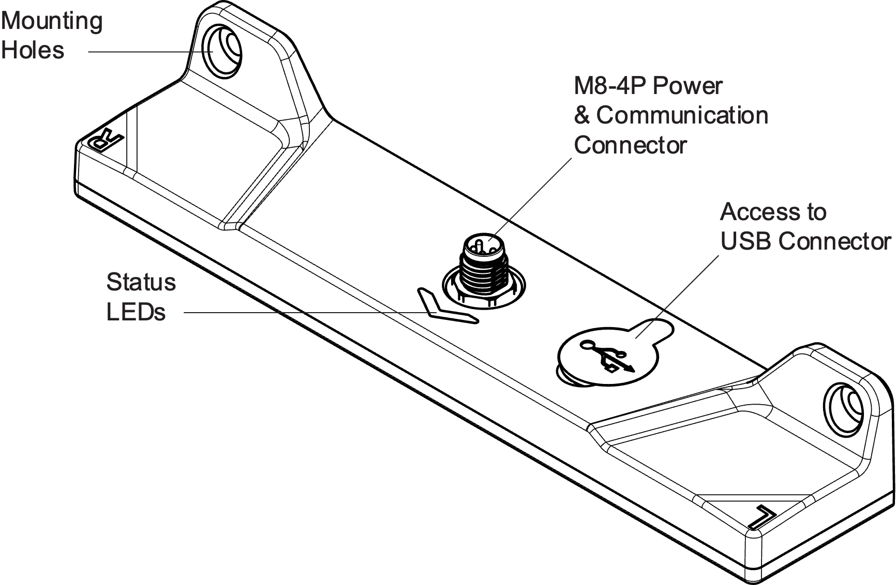

*Figure xx: MTS160D features identification and location*

#### Suitable magnetic materials

The sensor is designed to be compatible with magnetic tape that features a single pole pair (either north or south) with unipolar magnetization on one side, and it can accommodate various magnetic tape widths as well as various distances from the magnetic tape.

**The sensor will not work** with magnetic tape employing different forms of magnetization, such as alternating magnetization.

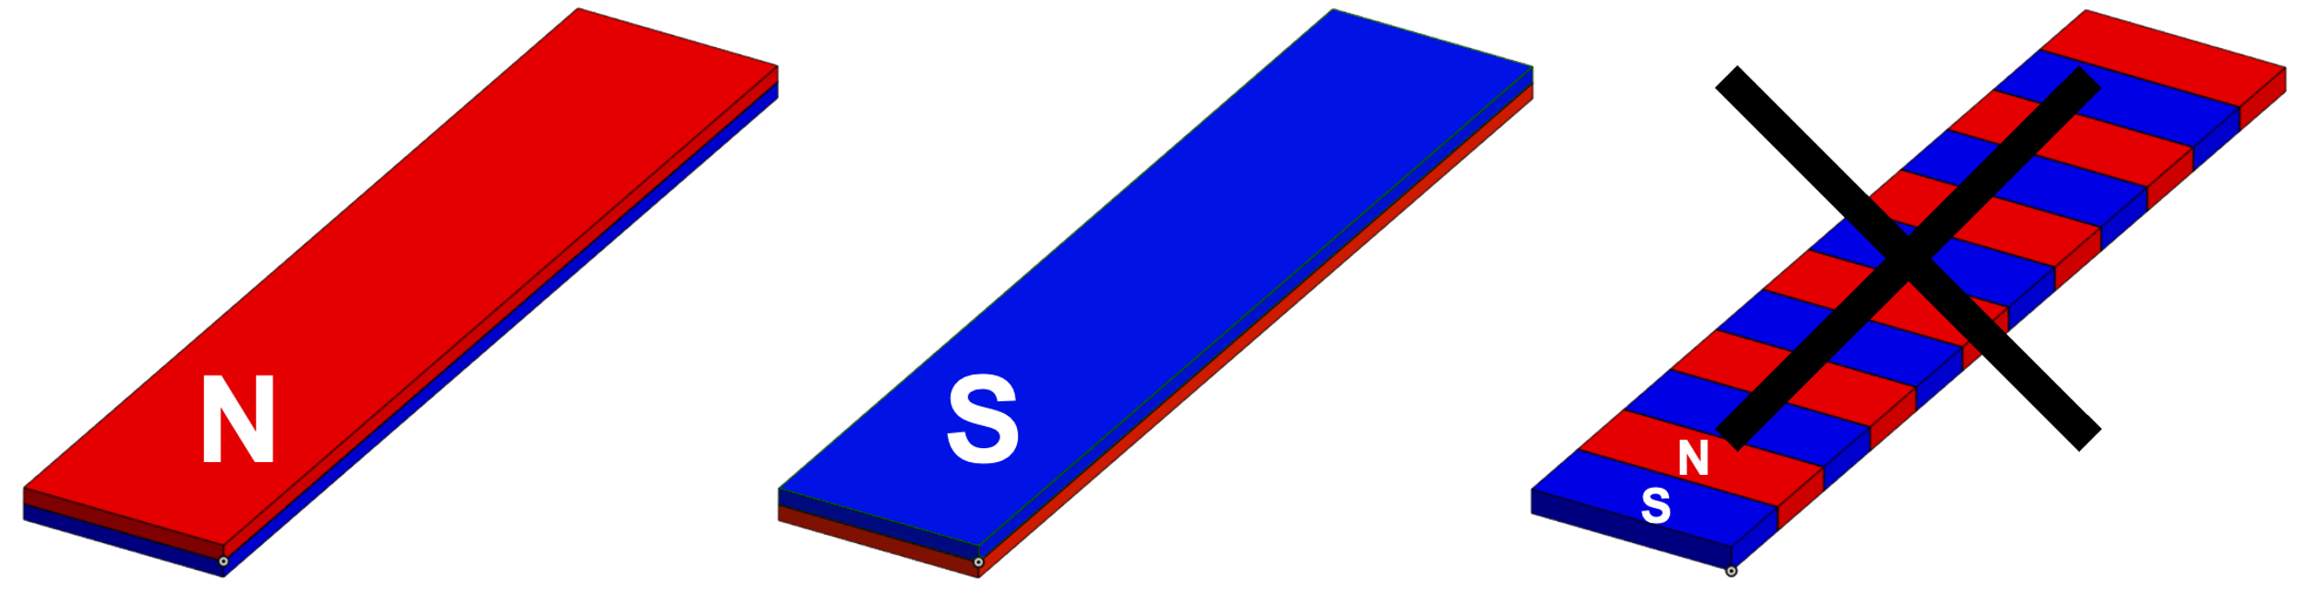

*Figure xx: Suitable magnetization.*

The figure below showcases various types of magnetic materials that are compatible with the sensor. The field strength and polarity graph above the materials visually indicates the varying magnetic field strength and direction across different points.

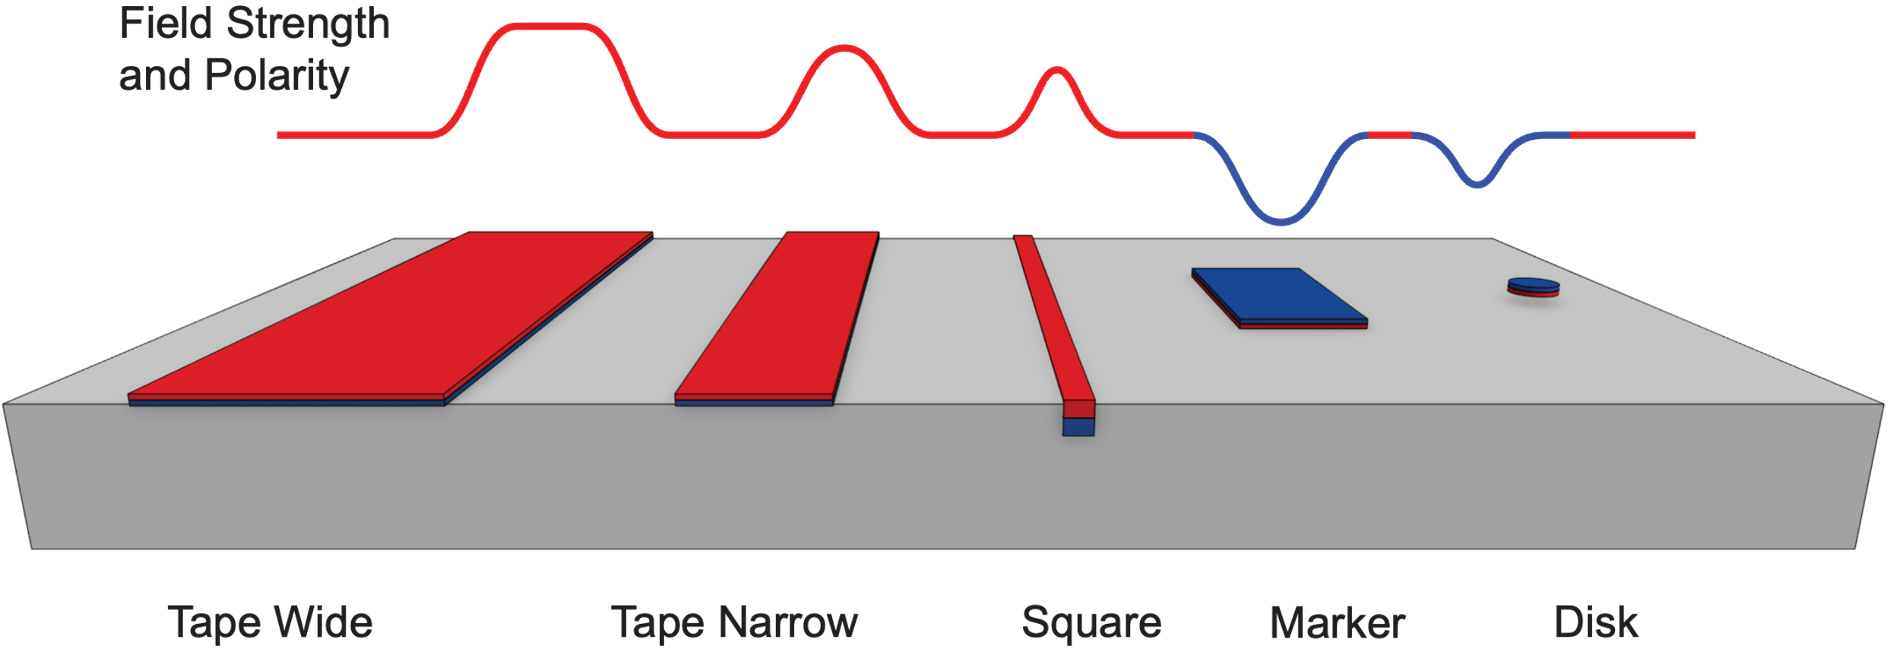

*Figure xx: Useable Magnetic Components*

## Tracking Tape

Use magnetized tape to lay the track for the robot to follow. Tape is available in wide (50mm typical) and narrow (25mm typical) versions. The wider tapes generate a stronger field and have higher adhesion to the floor. The narrow tapes are more cost-effective.

For area where there is high traffic of heavy equipment, flexible magnetic square profile can be inserted into the floor for best durability.

## Position Markers

Markers are identical to tracking tape but of inverse polarity. They are used to provides reference locations for the robots along the track.

## Point Source Disks

For more precise end-point positioning, the 10mm disks create a localized magnetic source which the sensor can use to align the robot in the X and Y direction.

MOUNTING 5

# Sensor Mounting

## Left/Right Identification

As a convention, Left and Right sides are relative to the sensor’s travel direction that is pointed by the arrow-shaped LED indicator, and are identified with the L and R letters engraved on the case.



Figure xx: Left/Right sides identification.

## Mounting Orientation and Height

The mounting location on the robot must be as free from magnetic disturbance fields as possible.

The sensor must be fitted on the robot so that it is as perfectly parallel to the floor as possible along the length and width direction.

Ideal sensor height is 20mm from the floor.

The sensor must be fitted with the M8 connector facing upward.

For best performance, the sensor must remain at a constant height from the floor as the robot moves along the track.

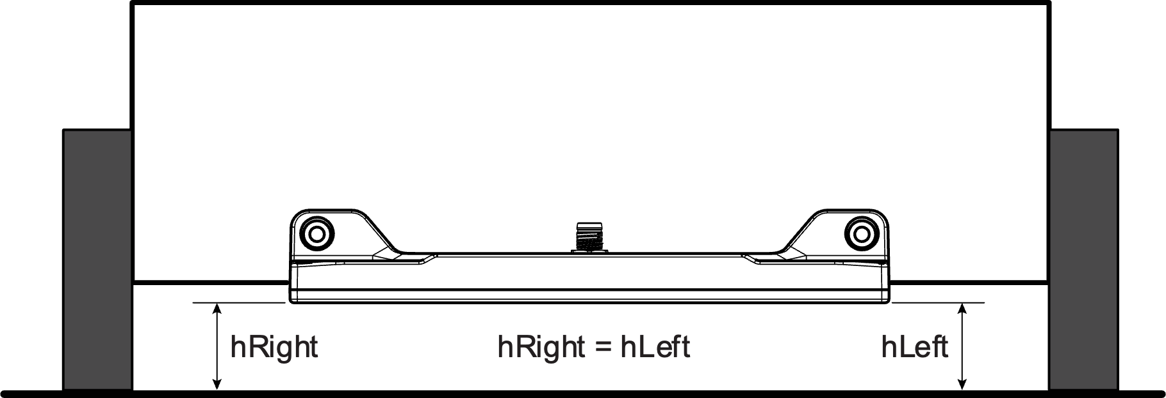

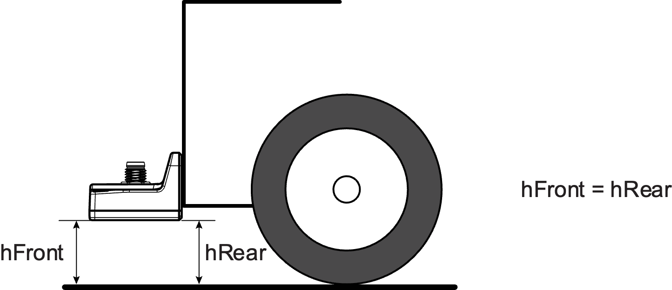

*Figure xx: Sensor Mounting location and orientation.*

The center point of the sensor should be positioned at the Robot’s center point, at a right angle to the direction of travel if possible.

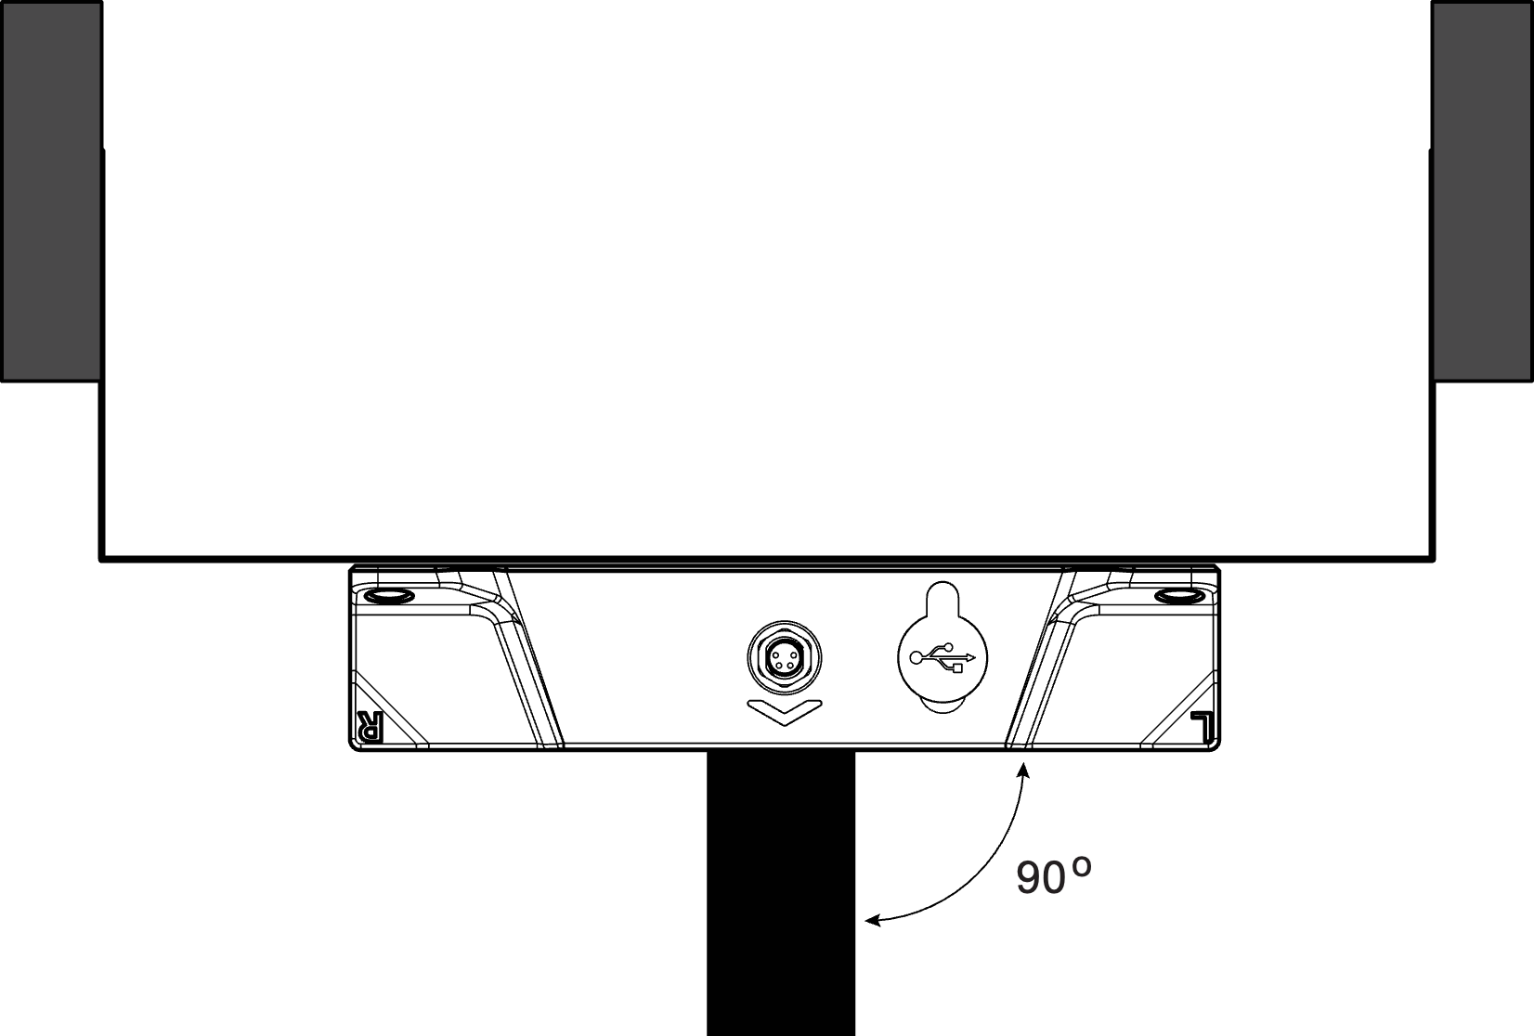

*Figure xx: Sensor Mounting location and orientation*

## Optimal Position for Steering

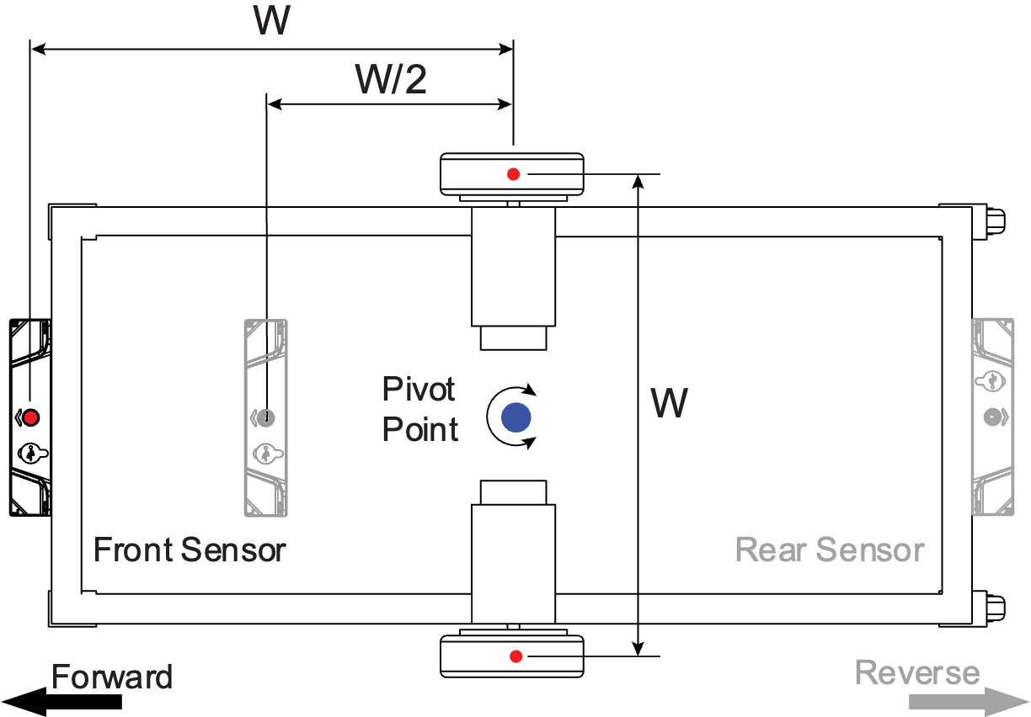

*Figure xx: Optimal Sensor Placement*

For robots using left/right motor-wheel arrangement the sensor must be placed at a distance relative to the wheel spacing W. To ensure that the robot can follow the magnetic path with precision and maintain control, the sensors should preferably be installed at a distance from the pivot point that falls between half the wheel spacing (W/2) and the full wheel spacing (W).

Placing the sensor too close or too far from the pivot points will make it more difficult to achieve stable and precise control.

The sensor must be placed ahead relative to the robot’s travel direction. For bidirectional control, sensors must be placed at both the front and rear ends of the robot.

## Physical Attachment

To mount the sensor onto the robot, select an accessible area on the robot where the sensor will be attached. Refer to the dimensions indicated in the diagram and measure the spacing for the mounting holes accordingly. The holes for the sensor are spaced 145 millimeters apart.

Position the holes 18.5mm higher than the desired height of the sensor above the floor. Drill two holes at these points that are sized appropriately for M4 screws and are drilled perpendicular to the mounting surface for a level attachment.

Align the sensor over the area, matching its mounting holes with those on the robot. Insert M4 stainless steel screws through the sensor's holes into the robot's holes. Stainless steel is preferred as it avoids the risk of magnetization, which could interfere with the sensor's functionality. Tighten the screws to secure the sensor in place, making sure it's firm but not overly tight to prevent any damage.

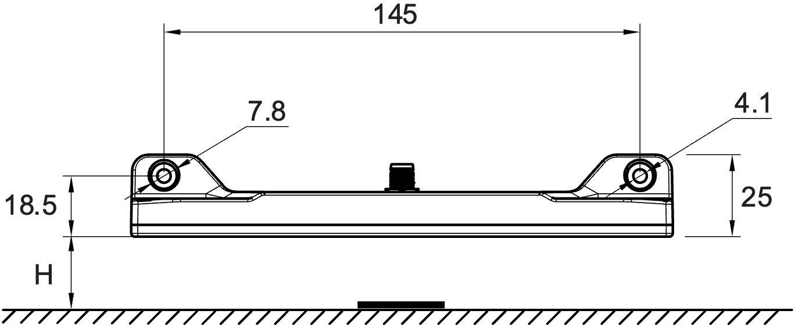

Figure xx: Dimensions for Mounting

# Electrical Connections

## M8 Connector Pin assignment

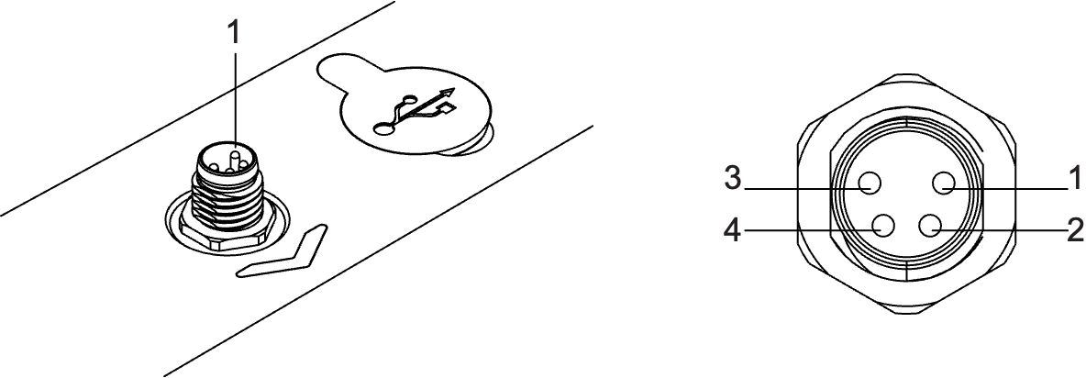

*Figure xx: Pin assignment: M8-male, A-coded, 4-pin*

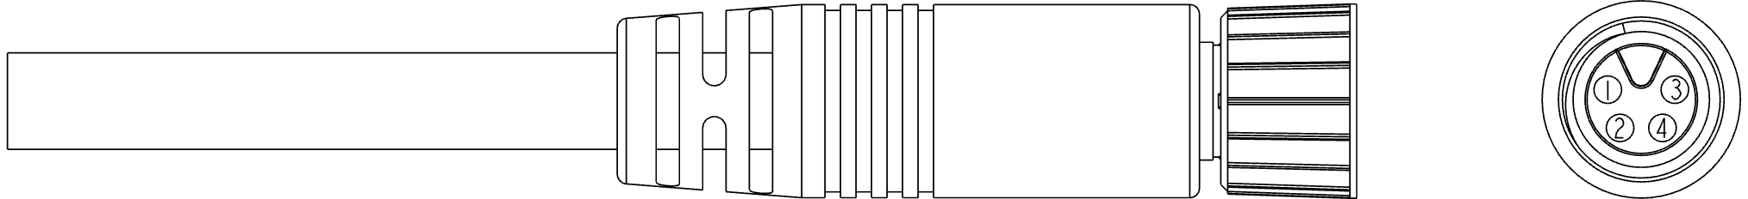

*Figure xx: Preassembled M8 Cable*

|  |  |  |  |
| --- | --- | --- | --- |
| Pin Number | Signal | Description | Wire Color |
| 1 | VIN+ | +5 to +28V Power Supply | Brown |
| 2 | CANH/RS232Tx/RS485A | Data Signal 1 | White |
| 3 | GND | Power Supply Ground | Blue |
| 4 | CANL/RS232Rx/RS485B | Data Signal 2 | Black |

## Connecting the supply voltage

The sensor must be connected to a stable voltage supply between 5V and 30 V DC and capable of sourcing at least 2 W power.

Always use the system’s main power switch to turn it on or off.

**Do not connect the M8 connector while the power is on. Always apply power after the connector is inserted.**

Note that when the sensor is connected to a PC or smartphone via the USB port, it will be powered on from these devices if there is no power on the M8 cable.

## 

# Data Connections

## Data Pin assignment

The MTS160D features a unique multi-interface, multi-protocol communication port that uses only two shared pins or the 4-pin connector. The choice of the protocol and interfaces are software selectable.



## CAN connection

The sensor allows for seamless integration with a CAN network by routing the CAN-High and CAN-Low signals to the two signal pins on the M8 connector.

It includes a built-in 120 Ohm termination resistor that can be activated via the Naviq PC Utility. The resistor is disabled by default.

When the built-in termination resistor is disabled, it is recommended to attach an external 120 Ohm terminator at both ends of the CAN bus network for optimal signal integrity.

## RS232 Connection

When RS232 communication is selected, the RS232 Tx (transmit) and Rx (receive) data signals are mapped to the designated pins on the connector.

To establish communication with another RS232 device within the system, connect these two data lines along with the Ground.

## RS485 Connection

When RS485 communication is selected, the A (direct) and B (complementary) data signals are mapped to the designated pins on the connector.

To establish communication with other RS485 device(s) within the system, connect these two data lines along with the Ground.

RS485 communication operates in half-duplex mode with 8 data bits, no parity, and one stop bit, with no flow control.

The sensor includes a built-in 120 Ohm termination resistor that can be activated via the Naviq PC Utility. The resistor is disabled by default.

When the built-in termination resistor is disabled, it is recommended to attach an external 120 Ohm terminator at both ends of the RS485 bus network for optimal signal integrity.

## USB Connection

The sensor can be directly connected to a PC or Smartphone via its USB C port that is located next to the M8 connector. After plugging in, the sensor will appear to the computer as a Serial Communication port.

The USB port is primarily used together with the Naviq utility for configuring, testing, and tuning the sensor.

While it will operate identically to the RS232 port, it is not recommended to use USB as the main communication interface with the navigation computer.

# Preparing the Sensor for Use

The MTS160D is ready for operation with only minimal configuration.

## Zero-Level Calibration

The sensor is calibrated at the factory. It may happen that the ambient magnetic level is different at the deployment location. It is therefore recommended to calibrate the sensor’s zero level at the final installation. To do so, position the robot away from the track or other magnetic source and issue the zeroing command using the available communication methods or via the PC utility.

## Tape Polarity Selection

In its factory default configuration, the sensor is set to detect and follow tracks made of tape with North polarity on the top side, and markers with South polarity on the top side. However, it can be adjusted to work with tape and markers that have the opposite magnetic polarity.

To check the tape's magnetic orientation, tie a strand of thin string around 50-100cm in length to a piece of tape. The tape's north-facing side will naturally align with the Earth's North Pole. As an alternative method, hold a compass against the top (non-sticky) side of the tape. You'll observe that the compass's north-facing needle is drawn towards the tape's south side, while its south-facing needle is drawn towards the north side.

Setting the tape polarity can be done via serial or CAN communication, or via the PC Utility.

## Track and Markers Threshold

The MTS algorithm looks for zones of increased magnetic strength to detect tracks, and zones of decreased magnetic strength to detect markers.

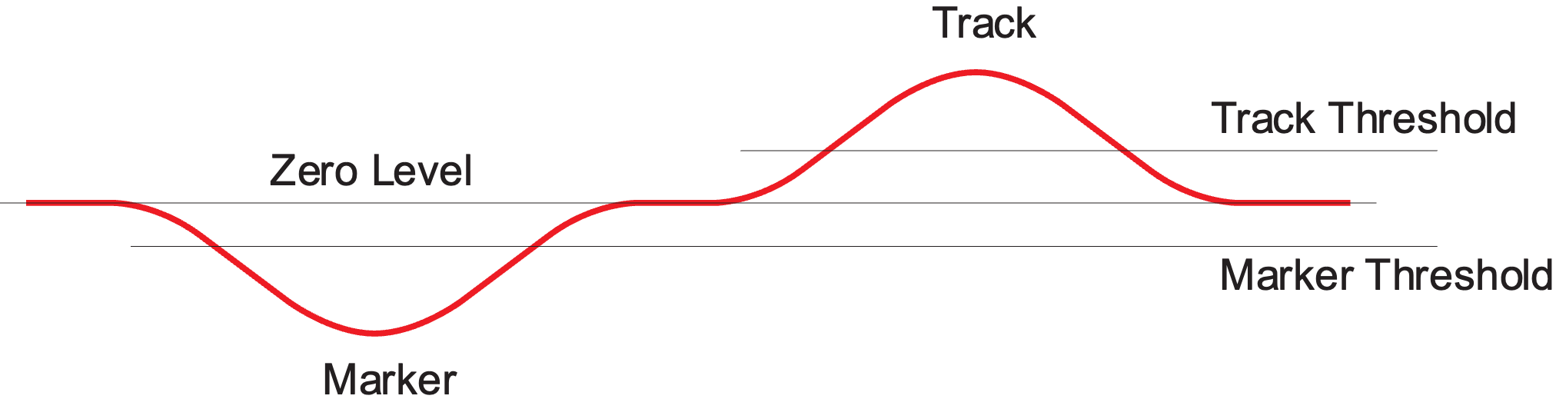

Figure xx : Track and Marker detection thresholds

## Communication Mode Selection

The MTS1600D can be configured to operate in the following modes:

* RS232 – Factory Default
* RS485
* SimpleCAN
* CANOpen

The MTS160 supports two distinct CAN communication protocols:

#### **SimpleCAN:**

A streamlined protocol delivering fixed frames that contain essential sensor data—such as track position, angle, and status—at a user-determined frequency. SimpleCAN frames are structured in a manner akin to CANOpen PDOs, but do not support SDO or network management capabilities.

#### **CANOpen:**

A broadly recognized, industry-standard communication protocol that ensures comprehensive network interaction and interoperability with other CANOpen devices.

## RS232 Configuration

RS232 communication is the factory default mode. It operates in full duplex mode with 8 data bits, no parity, and one stop bit, with no flow control. The sensor does not provide an echo for received commands.

Selectable bit rates are:

* 9600 bps
* 19200 bps
* 38400 bps
* 57600 bps
* 115200 bps – Factory default

For compatibility with devices that require TTL-level serial inputs, the RS232 signal levels can be inverted through configuration settings. Default is non-inverted.

To set the RS232 bit rate and the level inversion, use the USB port in conjunction with the Naviq PC utility software.

## CAN bus Configuration

Use the USB port in conjunction with the Naviq PC utility software to change the CAN settings.

CAN bus can be configured to operate at any the bit rates below:

* 125kbps
* 250kbps (default)
* 500kbps
* 1Mbps

The sensor’s CAN Node ID is user-selectable across the 7-bit range from address 1 to 127.

The sensor’s factory default address is 1.

When operating in CAN mode, the sensor will send its measurements inside Process Data Objects (PDOs) at a periodic rate. PDO send rate is user-selectable, from 5 to 1000ms. The factory default is 10ms (100Hz)

All the CAN settings described in this section apply to both SimpleCAN and CANOpen.

It is highly recommended to configure these settings before incorporating the sensor into an active network to prevent potential conflicts or disturbances with other networked devices.

# Sensor Data Reporting

The MTS160D measures and reports in real-time several parameters relative to the tracks and position markers. New data is evaluated at 200Hz, or every 5ms.

## Permanent Dual Track Detection

The MTS160D always reports data of two tracks simultaneously: One data set for Left and one for the Right track. This happens even if only one track is present. In that case, the data for the Left and Right tracks are identical. This scheme greatly simplifies and improves the handling of merges and forks and is discussed further below.

## Track Detection and Strength

The sensor will detect and report the presence of a track and its strength using two bits.

|  |  |  |  |
| --- | --- | --- | --- |
| **TS1** | **TS0** | **Track Detection** | **Magnetic Strength** |
| 0 | 0 | No Track | - |
| 0 | 1 | Track Present | Weak |
| 1 | 0 | Track Present | Medium |
| 1 | 1 | Track Present | Strong |

The sensor will operate correctly whenever a track is detected regardless of the magnetic strength. It is however strongly recommended to always have a Medium or Strong level at all locations around the path.

If the magnetic strength is weak, consider lowering the sensor closer to the track, or/and use magnetic tape with higher magnetization.

## Lateral Tracks Positions

The sensor reports the lateral position of the tracks relative to the center of the sensor. Values are in millimeters. Positions left of the center are negative values. Positions right of the center are positive values.

## Tape Incidence Angles

One of the MTS160D’s unique capabilities is the measure of the track’s incidence with the sensor. This enables the robot to distinguish between going off track, and therefore the need to apply only small trajectory corrections and entering a curve and therefore needing to apply sustained steering.

The sensor reports the incidence angle of each track with a 1-degree resolution



Figure xx : Angle and Lateral Position measurement

The benefits of using the angle and how to use it to optimize track following is discussed in detail further below in the document.

## Forks and Merges

The MTS160D supports a very effective forks and merges management technique that ensures precise and smooth, jolt-free, transitions.

It is based on the fact that the sensor always sees two tracks simultaneously, even if only one track is actually present.

When approaching a fork, and the sensor is over a single track, it will report two positions and two angle values. Assuming the robot is perfectly centered and aligned with the track, these will be 0mm and 0 degrees.

When entering the fork, the second track begins to register, and its position and angle is measured and reported. Depending on which branch the robot needs to follow, the navigation computer will use the left or the right track information for steering.

Assuming the left track is followed, the right track information will be ignored as the branches separate.

After the fork is cleared, the sensor only sees a single track again and the left and right values are identical again.

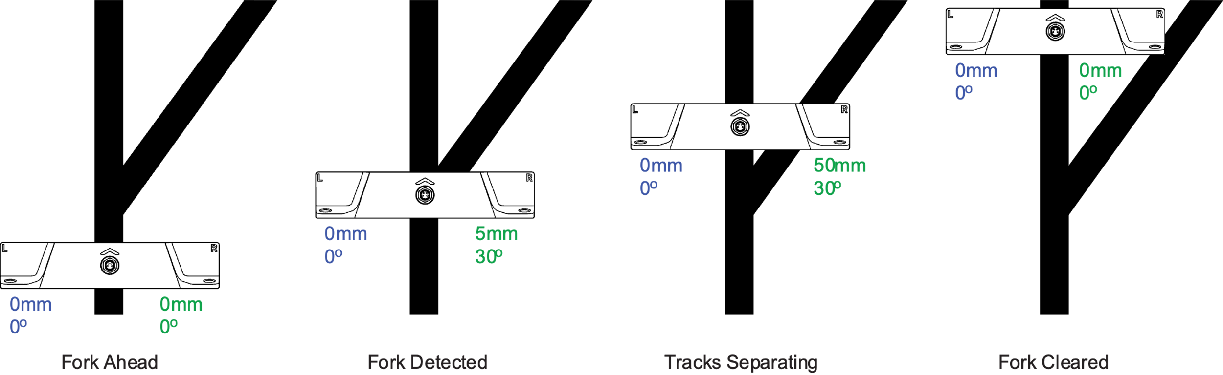

Figure xx: Sensor measurements at forks

Merges also use the fact that two position values are reported. Prior to entering a merge, the navigation computer must be set to follow the track that is opposite to this of the incoming branch. In the example below, the robot must be following the left track. As the robot progresses it will suddenly detect the track that is branching from the right, which it will simply ignore until the merge is complete.

**Beware that if the robot is set to follow the right track, it will abruptly steer to follow the right track as soon as it is detected.**

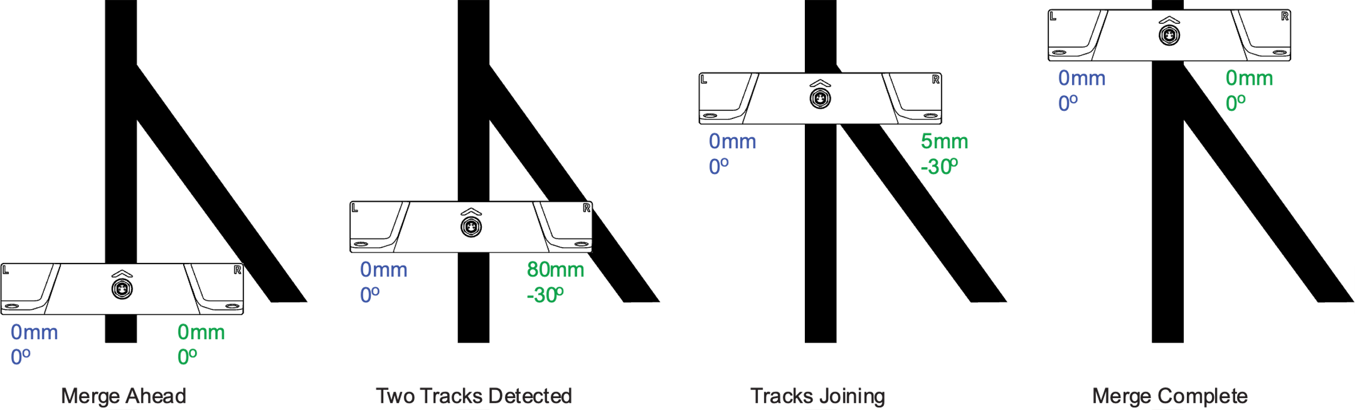

Figure xx: Sensor measurements at merges

## Left and Right Position Markers

Markers are special bits of magnetic strip that have the opposite polarity to the main track. They are typically used to identify special locations along the robot’s path. For instance, markers can indicate a fork ahead in the path, or a merge. They can tell the robot when it's approaching a charging station, or if it needs to adjust its speed, to either pick up the pace or slow down for safety.

The sensor can detect and report the presence of a Left Marker on the left side of the track, or a Right Marker one on the right side. Markers can be combined into patterns to uniquely identify more locations along the track.



Figure xx: Markers Types

It is recommended to use 25mm or longer markers. Markers that are too short will not have enough surface to ensure strong adherence to the floor. Markers shorter than 25mm may also have insufficient magnetic strength.

It is recommended to place the markers so that their edge is 20 to 30mm away from the edge of the main track. The sensor reports the lateral position of markers when detected.

## Navicode Coded Markers

The MTS160D is capable of detecting and decoding specially arranged combinations of left and right markers. The coding scheme can encode any number of bits using very simple base patterns for 1 and 0. These can then be concatenated to create multi-bit numbers.

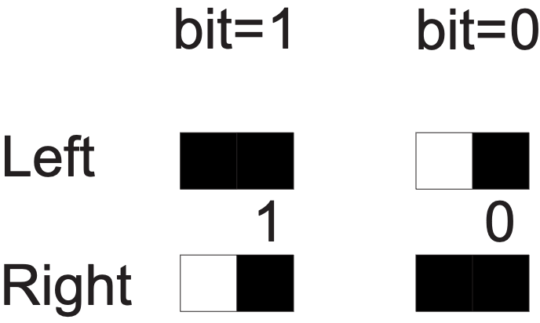

Figure xx: Base patterns for logic levels 1 and 0

The sensor will start the decoding process when a Left or Right marker is detected. The decoding takes place for as long as a marker is present on one side or the other. The decoding ends and value captured when no marker is longer present on either side.

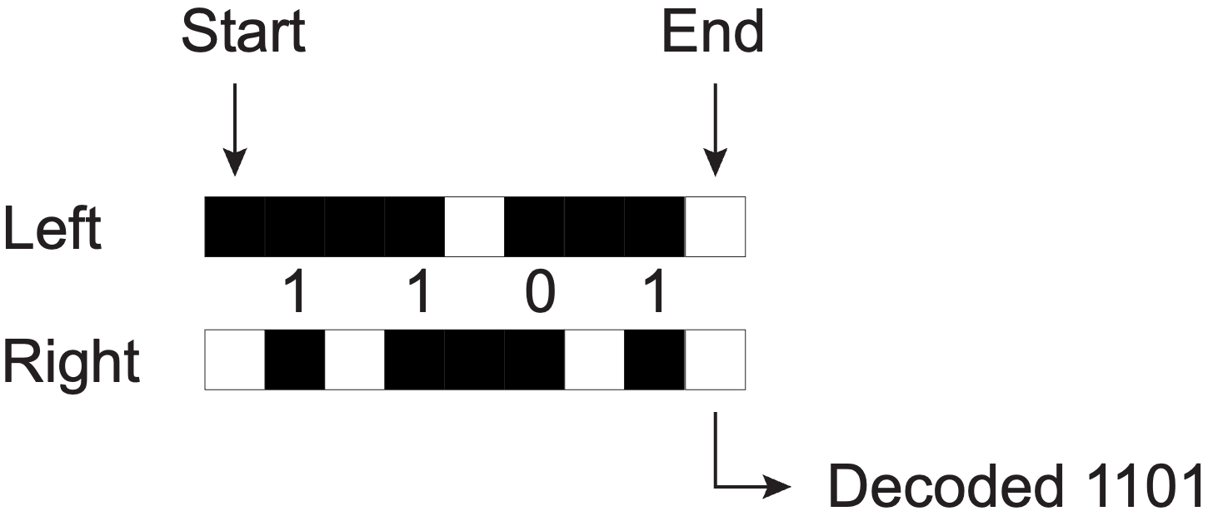

Figure xx: Example of 4-bit Navicode

Navicodes can be from one bit, and up to 16-bit long. When a code is successfully detected and recognized, the sensor will set a flag in the status word. The computer can then send a command to read the code’s value.

## Last-Millimeter Magnetic Point-Source

Another unique capability of the MTS160 is the detection along the X and Y axis of point-source disk magnets with millimeter accuracy. By installing one such magnet at a precise known location on each side of the track, it is possible to evaluate the robot’s exact position and orientation with very high precision.

This feature makes the sensor a valuable accessory for last-millimeter positioning on robots using laser or vision navigation.

Magnetic disks must be of opposite magnetic polarity than this of the main track. The sensor therefore detects them the same way as markers. In addition, the sensor will report their X and Y position.

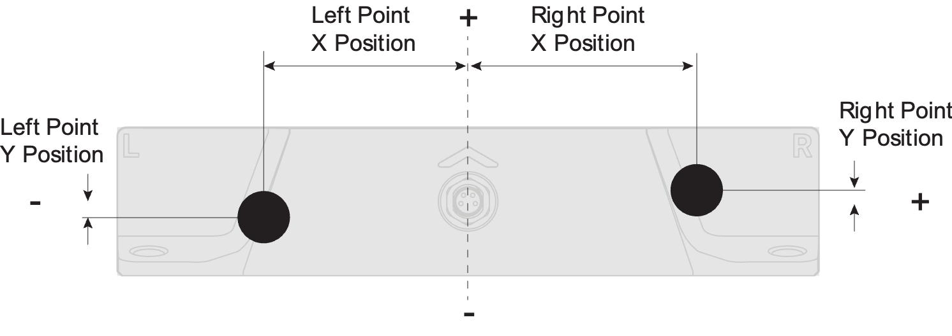

Figure xx: Detection of magnetic point-source

# Status LED Flashing Patterns

The MTS has two RGB LEDs behind the arrow-shaped window. It is used to provide visual clues about the state of the sensor and the magnetic elements found within its detection range.

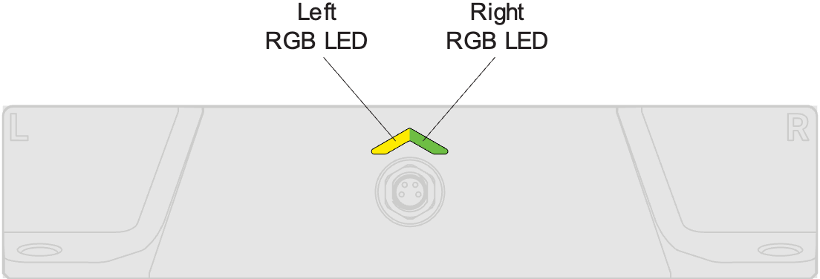

Figure xx: Status LED Indicator

|  |  |  |  |  |
| --- | --- | --- | --- | --- |
|  | Track  Detect | Left  Marker | Right  Marker |  |
|  | No | No | No | Steady blue indicates that the sensor is in a ready state but not currently engaged with a track and no markers or point-sources are within range |
|  | Yes | No | No | Steady green denotes that the sensor is successfully detecting a magnetic track, but no markers have been identified alongside the track. This indicates the sensor is following the path correctly but is not in proximity to any special markers. |
|  | Yes | Yes | No | Steady green on one half and steady yellow on the other indicates that the sensor is detecting a magnetic track and one marker on one side of the track. The yellow will be lit on the side of the marker. This state is used to indicate the detection of additional contextual points on the side of the main path. |
|  | Yes | No | Yes |
|  | Yes | Yes | Yes | Steady yellow denotes that the sensor is successfully detecting a magnetic track and markers on both sides of the track. This state is used to indicate the detection of additional contextual points on the sides of the main path. |
|  |  |  |  | Steady blue on one half and cyan on the other indicates that the sensor is detecting only one marker and no track. This state is used typically to detect point-source location magnets in non-line following applications |
|  |  |  |  |
|  |  |  |  | Steady cyan indicates that that the sensor is detecting markers only, and no track. This state is used typically to detect a pair of point-source location magnets in non-line following application. |
|  | No | No | No | Steady red indicates that the sensor is completely inactive or has encountered a critical error. |
|  | Pattern Dependent | | | Alternating red and any or the color patterns listed in this table indicates a sensor that failed one or more of its internal self-tests. It may still be operational and output data, however, robot operation must be stopped and the sensor be serviced as soon as possible. |

# Serial Commands

The MTS supports a set of ASCII text commands that can be exchanged on the RS232 and on the USB port. Commands are not case sensitive.

## ! Set

Commands starting with the ! character are used to send commands for the sensor to execute or for setting configuration parameters.

Configuration changes are stored in flash upon receiving and remain in effect when power is cycled.

If the command is successfully received without syntax errors, the sensor will reply by repeating the command followed by “OK”

Examples:

Set Zero Level: !ZERO

Reply: !ZERO,OK

Set Track Polarity to S on Top: !TPOL 1

Reply: !TPOL,OK

## ? Get

Commands starting with the ? character are used to request sensor live data, sensor fixed information, or to read configuration parameters. The sensor will reply by repeating the Command name, followed by a coma and the returned data.

Examples:

Get Firmware Revision: ?FWVR

Reply: ?FWVR,106,20240325,2882400018

Get Communication Configuration: ?SNCF

Reply: ?SNCF,50,50

## # Repeat

## @ Stop Repeat

Commands starting with the # character are Get commands identical to these above, except that the sensor will send a reply with new data repeatedly. The repeat rate is determined by a value in milliseconds, separated by a coma, at the end of the command.

Multiple repeat commands can be running at the same time all with their own repeat rate.

Sending the @ character stops all the running repeat commands.

Example:

Get Sensor Values every 10ms: #SALL,10

Repeating reply: ?SALL,0,0,0,0,0,0,0,0,0,0,0,250

## Command List

**ZERO** – Calibrate Zero Level Category: Set Commands

Description:

Captures and stores the ambient magnetic field strength at each internal sensor when no track or markers are present. Subtracts these values from subsequent reading.

Syntax: !ZERO

Arguments: None

**RSET** – Rest to Factory Defaults Category: Set Commands

Description:

Resets all configuration parameters to their factory default values.

Syntax: !RSET

Arguments: None

**SALL** – Read All Sensor Data Category: Get Sensor Data

Description:

Read all the sensor’s measurements into a single string. Values are coma delimited and determined by their order. An 8-bit counter is sent at the end of the string. The counter increments every time SALL is invoked, either by a new ?Get or #Repeat.

Syntax: ?SALL

Arguments: None

Reply: ?SALL,TDet,LTPos,LTAng,RTPos,RTAng,LM,RM,LMPos,RMPos,Count

1-TDet: Track Detect

Type: 4-bit Units: milliTeslas Range: 0-3

2-LTPos: Left Track Position

3-RTPos: Reft Track Position

Type: Signed 8-bit Units: Millimeters Range +/-80

4-LTAng: Left Track Angle

5-RTAng: Reft Track Angle

Type: Signed 8-bit Units: Degrees Range +/-90

6-LM: Left Marker Detect

7-RM: Right Marker Detect

Type: bool Units: - Range: 0-1

8-LMPos: Left Track Position

9-RMPos: Reft Track Position

Type: Signed 8-bit Units: Millimeters Range +/-80

10-Count: Frame Counter

Type: unsigned 8-bit Units: - Range 0-255

**RSEN** – Read Internal Sensor Values Calibrated Category: Get Sensor Data

Description:

Read the value of each of the 32 internal magnetic sensors. Returns value corrected with the zero offset.

Syntax: ?RSEN

Arguments: None

Reply: ?RSEN,Value1,Value2, …,Value32

Value(n)

Type: Signed 16-bit Units: milliTeslas Range: +/-16000

**RAWS** – Read Internal Sensor Values Uncalibrated Category: Get Sensor Data

Description:

Read the value of each of the 32 internal magnetic sensors. Returns value witout the zero offset correction.

Syntax: ?RAWS

Arguments: None

Reply: ?RAWS,Value1,Value2, …,Value32

Value(n)

Type: Signed 16-bit Units: milliTeslas Range: +/-16000

**STAT** –Read Sensor Status Category: Get Sensor Data

Description: Read the sensors status flags

Syntax: ?STAT

Arguments: None

Reply: ?STAT,Flags

Flags

Type: Unsigned 8-bit Units: 0 Range: -

|  |  |  |  |  |  |  |  |
| --- | --- | --- | --- | --- | --- | --- | --- |
| Bit 7 | Bit 6 | Bit 5 | Bit 4 | Bit 3 | Bit 2 | Bit 1 | Bit 0 |
| - | - | - | Sensor  Fault | Track Detect | | Left  Marker  Detect | Right  Marker  Detect |

**TPOL** – Tape Polarity Category: Configuration

Description:

Select whether tracking tape has magnetic North or South on top side. Markers setting will also change so that they are opposite polarity than track.

Set Syntax: !TPOL,Polarity

Get Syntax: ?TPOL

Reply: ?TPOL,Polarity

Polarity

0: North on Top

1: South on Top

**CMCF** – Communication Mode Category: Configuration

Description:

Select the sensors communication mode and protocol

Set Syntax: !CMCF,Mode

Get Syntax: ?CMCF

Reply: ?CMCF,Mode

Mode

0: RS232 (Factory Default)

1: SimpeCAN

2: CANOpen

**RSCF** – RS232 Configuration Category: Configuration

Description:

Defines the parameters necessary for RS232 operation.

Set Syntax: !RSCF,NodeId, Bitrate,TPDOPeriod,TermResistor

Get Syntax: ?RSCF

Reply: ?RSCF,Bitrate,Inverted

Name: baudrate, Type: uint32_t, Description: Baudrate, Options: [9600, 19200, 38400, 57600, 115200]; Name: inverted, Type: uint8_t, Description: Inverted, Options: [0: False, 1: True]

Baudrate

0: 9600

1: 19200

2: 38400

3: 57600

4: 115200 (Factory Default)

Inverted – Rx and Tx signal inversion

0: Not inverted (Factory Default)

1: Inverted

**CNCF** – CAN Configuration Category: Configuration

Description:

Defines the parameters necessary for CANOperation. These parameters are common to SimpleCAN and CANOpen.

Set Syntax: !CNCF,NodeId, Bitrate,TPDOPeriod,TermResistor

Get Syntax: ?CNCF

Reply: ?CNCF,NodeId, Bitrate,Period,TermResistor

NodeId

Type: Unsigned 8-bit Units: - Range: 1-127

Default: 1

Bitrate

0: 125kbits/s

1: 250kbits/s (Factory Default)

2: 512kbits/s

3: 1000kbits/s

Period - TPDO Send Period)

Type: Unsigned 16-bit Units: milliseconds Range: 0-65536

Default: 20

TermResistor - 120 ohm Termination Resistor

0: Disabled (Factory Default)

1: Enabled

**FWVR** – Read Firmware Version Category: Get Sensor Information

Description:

Read the Firmware revision and date.

Syntax: ?FWVR

Reply: ?FWVR,Revision,Date,FirmwareHash

Revision

Type: Unsigned 32-bit Format: 010203 = 1.2.3

Date

Type: Unsigned 32-bit Format: YYYYMMDD

FirmwareHash

Type: Unsigned 32-bit

**SNID** – Read Sensor Hardware Id Category: Get Sensor Information

Description:

Read the sensor’s unique Hardware Identification number

Syntax: ?SNID

Reply: ?SNID,HardwareId

HardwareId

Type: Unsigned 32-bit

# SimpleCAN Communication

SimpleCAN is a very simplified subset of CANopen where the sensor sends periodically all the track and marker reading into a single standard CAN frame. SimpleCAN frames can easily be captured and parsed with a few lines of code on most systems.

The SimpleCAN frame is formatted to mimic CANOpen Transmit Process Data Objects (TPDOs). However, SimpleCAN is not CANOpen compatible: It does not support Service Data Objects (SDOs), Network Management (NMT), SYNC or other CANOpen objects.

When SimpleCAN is enabled, sensor automatically starts sending sends data frames immediately after power up, at a user defined Repeat Rate, with no way to stop it. The sensor can only send. It cannot receive CAN frames.

SimpleCAN frames and TPDOs are very simple standard CAN frames composed of a Header, a Byte Count, and a 1 to 8 bytes Payload. In the case of the MTS160D, the frame is composed as follows:

|  |  |  |
| --- | --- | --- |
| Header | Byte Count | Payload |
| 0x180 + NodeID | 6 | 6 Bytes Payload |

Frame Payload:

|  |  |  |  |  |  |
| --- | --- | --- | --- | --- | --- |
| Byte 1 | Byte 2 | Byte 3 | Byte 4 | Byte 5 | Byte 6 |
| Left  Position | Right Position | Left  Angle | Right  Angle | Status  Flags | Frame  Counter |

The Track position and angle values are signed bytes.

Status Flags Byte Detail:

|  |  |  |  |  |  |  |  |
| --- | --- | --- | --- | --- | --- | --- | --- |
| Bit 7 | Bit 6 | Bit 5 | Bit 4 | Bit 3 | Bit 2 | Bit 1 | Bit 0 |
| - | - | - | Sensor  Fault | Track Detect | | Left  Marker  Detect | Right  Marker  Detect |

The Frame Counter is an unsigned 8-bit value that increments every time a frame is sent. It can be used by the system’s computer as a heartbeat signal, and to check that no frames have been lost.

Both the NodeId and the Repeat Rate are configured via USB and the Naviq PC Utility

# CANOpen Communication

# 8 Operation

All sensor functions can be accessed via the CANopen interface. All settings can be configured in this interface.

The EDS file can also be found at [www.NavIQ.com/MTS160](http://www.sick.com/mls)

## CANopen standard objects

This section only describes the SDOs that do not have a fixed definition in the CANopen standard. Default values are listed only for parameters that can be modified by the user.

*Table 1: SDOs*

|  |  |  |  |  |  |
| --- | --- | --- | --- | --- | --- |
| Index | Sub | R/W | Object name | Default value | Description |
| 0x1000 |  | RO | Device type | - | No device profile supported |
| 0x1001 |  | RO | Error register | - |  |
| 0x1008 |  | RO | Manufacturer device name | - | NAVIQ |
| 0x1009 |  | RO | Manufacturer hardware version | - | Hardware version, sensor |
| 0x100A |  | RO | Manufacturer software version | - | Firmware version, sensor |
| 0x1018 |  |  | Identity object |  |  |
|  | 1 | RO | Vendor-ID | - | 0x01000056 (NAVIQ) |
|  | 2 | RO | Product code | - | 0x00001100 (MTS160) |
|  | 3 | RO | Revision number | - | 0x00000001 |
|  | 4 | RO | Serial number | - | Format: YYYYWWnnnn  YYYY: Year of production WW: Week of production nnnn: Sequential number |
| 0x1800 |  |  | Transmit PDO communication parameter 0 |  |  |
|  | 1 | R/W | COB ID | 0x0000018  A | see "Transmission types", page 25 |
|  | 2 | R/W | Transmission type | 0xFF | see "Transmission types", page 25 |
|  | 5 | R/W | Event timer | 0x000A | see "Transmission types", page 25 |
| 0x1801 |  |  | Transmit PDO communication parameter 1 |  |  |
|  | 1 | R/W | COB ID | 0xFF07008  0 | see "Transmission types", page 25 |
|  | 2 | R/W | Transmission |  | see "Transmission types", page 25 |
|  | 5 | R/W | Event timer |  | see "Transmission types", page 25 |
| 0x2019 |  | RO | Order number | - |  |
| 0x2020 |  | WO | Password | - |  |

|  |  |  |  |  |  |
| --- | --- | --- | --- | --- | --- |
| Index | Sub | R/W | Object name | Default value | Description |
| 0x2021 |  |  |  |  |  |
|  | 1 | RO | LCP1 | - | see "Process data objects", page 24 |
|  | 2 | RO | LCP2 | - | see "Process data objects", page 24 |
|  | 3 | RO | LCP3 | - | see "Process data objects", page 24 |
|  | 4 | RO | #LCP | - | see "Process data objects", page 24 |
|  | 5 | RO | LCP1_width | - | see "Process data objects", page 24 |
|  | 6 | RO | LCP2_width | - | see "Process data objects", page 24 |
|  | 7 | RO | LCP3_width | - | see "Process data objects", page 24 |
| 0x2022 |  | RO | Status | - | see "Process data objects", page 24 |
| 0x2023 |  | RO | Line level | - | see "Process data objects", page 24 |
| 0x2024 |  | RO | Field level | - | Measured magnetic  field strength in digits |
| 0x2025 |  | R/W | Min. level | 600 | Minimum magnetic field strength in digits above which a line is detected |
| 0x2026 |  | R/W | Offset | 0 | Offset [mm] for sensor zero point |
| 0x2027 |  | R/W | Sensor flipped | 0 | see "Process data objects", page 24 |
| 0x2028 |  |  | Marker detection |  |  |
|  | 1 | R/W | Use markers | 0 | 0 => No marker detected in TPDO 1 => Detected markers displayed in TPDO1 |
|  | 2 | R/W | Marker style | 0 | 1. => No marker detec‐tion 2. => NAVIQ marker stan‐dard mode 2 => NAVIQ marker extended mode see "Marker detection", page 28 |
|  | 3 | R/W | Failsafe mode | 0 | 1. => Failsafe modedeactivated 2. => Failsafe mode acti‐vated see "Marker detection", page 28 |
| 0x2029 |  | R/W | Lock teach | 0 | 1. => Teach key acti‐vated 2. => Teach key deacti‐vated |
| Index | Sub | R/W | Object name | Default value | Description |
| 0x202A |  | WO | Set param. to default | - | 1 => All parameters are set to factory defaults  NOTE  To reset the parameters  “Transmission type” and “Event timer”, a communication reset must also be performed. |
| 0x202B |  | WO | Trigger user offset calibration | - | 1 => Offset calibration of the magnetic field is performed; the sensor is then restarted |
| 0x202C |  | WO | Trigger zero point adjustment | - | 1 => Teaches the current position as the new zero point |

#### 8.1.2 Process data objects

The MTS160 has two TPDOs (TPDO1 and TPDO2) with fixed mapping and no RPDO. TPDO1 can be accessed under the index 0x0180 + node ID, TPDO2 under the index 0x0182 + node ID. In its default state (node ID 0x0A), the index for TPDO1 is 0x018A.

The TPDO1 is structured as follows:

*Table 2: TPDO1*

|  |  |  |  |  |  |  |  |  |  |  |
| --- | --- | --- | --- | --- | --- | --- | --- | --- | --- | --- |
|  | Byte 1 | Byte 2 | | Byte 3 | Byte 4 | | Byte 5 | Byte 6 | Byte 7 | Byte 8 |
| TPD01 | LSB  LCP1 | MSB  LCP1 | | LSB  LCP2 | MSB  LCP2 | | LSB  LCP3 | MSB  LCP3 | #LCP | Status |
| Value | | | Data type | | | Description | | | | |
| LCP1 | | | INT16 | | | Position of line center point 1 [mm] | | | | |
| LCP2 | | | INT16 | | | Position of line center point 2 [mm] | | | | |
| LCP3 | | | INT16 | | | Position of line center point 3 [mm] | | | | |
| #LCP | | | - | | | See table #LCP | | | | |
| Status | | | - | | | See status table | | | | |

*Table 3: TPDO1, byte 7: #LCP*

|  |  |  |  |  |  |  |  |  |  |  |
| --- | --- | --- | --- | --- | --- | --- | --- | --- | --- | --- |
|  | Bit 0 | Bit 1 | | Bit 2 | Bit 3 | | Bit 4 | Bit 5 | Bit 6 | Bit 7 |
| #LCP | #LCP  Bit 0 | #LCP  Bit 1 | | #LCP  Bit 2 | Marker  Bit 0 | | Marker  Bit 1 | Marker  Bit 2 | Marker  Bit 3 | Marker  Bit 4 |
| Value | | | Data type | | | Description | | | | |
| #LCP | | | UINT3 | | | The numbers are assigned the following meanings:  0 => No line found   1. => One line found 2. => Two lines found: Right diverter 3. => Two lines found: Left diverter 4. => Three lines found | | | | |
| Marker | | | INT5 | | | Bit 0 is the introductory character bit  Bits 1 to 4 represent codes 1 to 15 | | | | |

*Table 4: TPDO, byte 8: Status*

|  |  |  |  |  |  |  |  |  |  |  |  |  |  |
| --- | --- | --- | --- | --- | --- | --- | --- | --- | --- | --- | --- | --- | --- |
|  | Bit 0 | Bit 1 | | Bit 2 | Bit 3 | | Bit 4 | | Bit 5 | Bit 6 | | Bit 7 | |
| Status | Line good | LineLev  Bit 0 | | LineLev  Bit 1 | LineLev  Bit 2 | | Sensor flipped | | Polarity | Reading code | | 0 | |
| Value | | | Data type | | | Description | | | | | | |
| Line good | | | BOOL | | | 1. => No line or line too weak 2. => Sufficiently strong line detected | | | | | | |
| LineLev | | | UINT3 | | | Indication of magnetic field strength in accordance with the following table: | | | | | | |
| FieldLevel | | LineLevel | | | Distance to line tape* | |
| > 2750 | | 7 | | | 22 mm | |
| > 2500 | | 6 | | | 23 mm | |
| > 2000 | | 5 | | | 26 mm | |
| > 1750 | | 4 | | | 29 mm | |
| > 1500 | | 3 | | | 31 mm | |
| > 1250 | | 2 | | | 34 mm | |
| > 1000 | | 1 | | | 39 mm | |
| > 750 | | 0 | | | 47 mm | |
| < 750 | | 0 | | | 47 mm | |
| * NAVIQ line tape, item part no. 5337613 | | | | | | |
| Sensor flipped | | | BOOL | | | Indicates whether or not the measuring range has been inverted   1. => Negative positions on cable outlet side 2. => Positive positions on cable outlet side | | | | | | |
| Polarity | | | BOOL | | | Indicates whether the upper surface of the magnetic tape is magnetized to the north or south pole 0 => North pole  1 => South pole | | | | | | |
| Reading code | | | BOOL | | | 1. => No code present to read 2. => Sensor is reading code | | | | | | |

The TPDO2 is structured as follows:

|  |  |  |  |
| --- | --- | --- | --- |
| Byte | Value | Data type | Description |
| 1 | LCP1_width | UINT8 | Lane width [mm] |
| 2 | LCP2_width | UINT8 | Lane width [mm] |
| 3 | LCP3_width | UINT8 | Lane width [mm] |

#### 8.1.3 Transmission types

The various transmission types of the TPDO1 can be set in indexes 0x1800 (TPDO1) and 0x1801 (TPDO2). These indexes are each comprised of the following subindexes:

|  |  |  |  |
| --- | --- | --- | --- |
| Subind ex | Name | Permissible values | Description |
| 1 | COB-ID | - | The COB ID is automatically adjusted to the note ID and should not be amended by the user. |
| Subind ex | Name | Permissible values | Description |
| 2 | Transmission type | 0xFE,  0xFF | The transmission type is set here. The MTS160 only supports event-driven transmission; the permissible values are 0xFE and 0xFF |
| 3 | Not used | - | Not used |
| 4 | Compatibility entry | - | Not used |
| 5 | Event timer | 0 ...  65535 | The event timer sets the time between two transmissions from the TPDO in [ms]. A value of 0 deactivates the transmission of the process data. |

# Connecting and Using the PC Utility

## Connecting the Sensors

Via USB

Autodetect and auto launch (chrome or edge)

## Dashboard

Description

## Configuration

Configuration

### Technical data

#### Performance

*Table 7: Performance*

|  |  |  |  |  |  |  |
| --- | --- | --- | --- | --- | --- | --- |
| Parameter | Conditions | Icon | Unit | min. | Typ. | max. |
| Measuring range |  | MR300 | mm |  | 300 |  |
| Repeatability1 |  |  | mm |  |  | 1 |
| Resolution |  |  | mm |  |  | 1 |
| Working distance2 |  |  | mm | 10 |  | 50 |
| Output refresh rate3 |  |  | Hz |  |  | 100 |
| LED display | |  |  | yellow / red, blue / green | | |
| Reverse polarity protection | |  |  | Yes | | |
| Short-circuit protection | |  |  | Yes | | |

1 Depending on magnetic tape used and working distance 2 Depending on magnetic tape used 3 Depending on sensor length:

|  |  |
| --- | --- |
| Parameter | Specification |
| Electrical connection | PUR cable 0.3 m; M8 4-pin or  PUR cable 0.3 m; M12, 4-pin or  PUR cable 2 m; cable outlet (open strand end) |
| Supply voltage | 9 … 30 V DC, reverse polarity protected |
| Residual ripple | </= 10% |
| Power consumption | </= 600 mW |
| Housing | Aluminum, PA |
| Housing color | black, end caps: black |

200: 100 Hz

300: 100 Hz

400: 80 Hz

500: 70 Hz

600: 60 Hz

#### Interfaces

*Table 8: Interfaces*

|  |  |
| --- | --- |
| Parameter | Specification |
| Interface | CANopen |
| Device profile | No device profile is supported |
| Address setting | 0 … 127, default: 10 |
| Data transmission rate | 10 kBaud … 1000 kBaud, default: 125 kBaud |
| PDO data | LCP1 … 3, #LCP, status |
| Configuration data | Minimum permissible magnetic field strength, offset zero point, inversion of measuring range, marker detection, activation of teach-in button |
| Diagnostic data | Current magnetic field strength |
| Status information | No LED allocated on CANopen bus |
| Bus termination | Internal 120 Ohm terminator (optional) |

#### Mechanics/electronics

*Table 9: Mechanics/electronics*

|  |  |  |  |
| --- | --- | --- | --- |
| Parameter | | Specification | |
| EMC | | In accordance with DIN 61000-6-2/4 | |
| Protection class | | 3 | |
| Enclosure rating | | IP 65, IP 67, IP 68 (in accordance with EN  60529) | |
| Mounting | | Mounted using accessories in sensor T-slot | |
|  | Total length | | Measuring range |
| MTS160E-0200 | 217 | | 200 |
| MTS160E-0300 | 325 | | 300 |
| MTS160E-0400 | 397 | | 400 |
| MTS160E-0500 | 505 | | 500 |
| MTS160E-0600 | 613 | | 600 |

#### Ambient data

*Table 10: Ambient data*

|  |  |
| --- | --- |
| Parameter | Specification |
| Perm. impact load | 30 g/11 ms |
| Perm. vibration load | 10 ... 55 Hz/1 mm |
| Perm. ambient temperature | -20 °C ... 70 °C |

### Maintenance

#### Maintenance

The sensor is maintenance-free.

To ensure it continues operating without problems, however, the screw connection between the sensor and the slot, and for the electrical connection, should be checked regularly. The interval at which they are checked should be adapted in line with the conditions of the application, but should be no more than 6 months.

#### Repairs

Repairs on the sensor may only be carried out by the manufacturer. Any interruption or modification of the sensor will invalidate the manufacturer warranty.

### Troubleshoting

|  |  |  |
| --- | --- | --- |
| LED indicator/fault pattern | Cause | Measures |
| No LED illuminated/sensor not communicating via CANopen | Problem with sensor voltage supply | Check and restore voltage supply |
| Green LED flashing/sensor does not output line data even though line tape is positioned at the correct distance | Threshold for detection of line tape is set too high | Reduce threshold for detection of line tape (index  0x2025) |
| Yellow LED lights up/sensor does not output line data | Event timer TPDO1 is set to '0' | Set event timer (index 0x1800 subindex 3) to a value greater than 10 |
| Sensor does not send TPDO2 | TPDO2 not activated | Activate TPDO2 via COB ID |

TECHNICAL DATA 12

### 12

Copyright Notice

This material is subject to copyright protection. All copyright-related rights are exclusively held by NAVIQ. Duplication or partial reproduction of this material is permitted only to the extent allowed under the prevailing Copyright Act. Altering, condensing, or translating this material is not allowed without prior written consent from NAVIQ.

The trademarks mentioned herein belong to their respective owners.

© NAVIQ. All rights reserved.

# 2 Safety information

## 2.1 Intended use

The MTS160 sensor is a non-contact sensor used to determine the position of a magnetic line tape.

NAVIQ assumes no liability for losses or damage arising from the use of the product, either directly or indirectly.

## 2.2 Improper use

* The sensor does not constitute a safety-relevant device according to the EC Machinery Directive (2006/42/EC).
* The sensor must not be used in explosion-hazardous areas.
* Any other use that is not described as intended use is prohibited.
* Any use of accessories not specifically approved by NAVIQ is at your own risk.

Danger due to improper use!

Any improper use can result in dangerous situations.

Therefore, take note of the following information:

b The sensor should be used only in line with intended use specifications. b All information in these operating instructions must be strictly complied with.

## 2.3 Limitation of liability

Applicable standards and regulations, the latest state of technological development, and our many years of knowledge and experience have all been taken into account when assembling the data and information contained in these operating instructions. The manufacturer accepts no liability for damage caused by:

■ Failing to observe the operating instructions

■ Improper use

■ Use by untrained personnel

■ Unauthorized conversions

■ Technical modifications

■ Use of unauthorized spare parts, consumables, and accessories

With special variants, where optional extras have been ordered, or owing to the latest technical changes, the actual scope of delivery may vary from the features and illustrations shown here.

## 2.4 Requirements for skilled persons and operating personnel

WARNING

Risk of injury due to insufficient training.

Improper handling of the sensor may result in considerable personal injury and material damage.

■ All work must only ever be carried out by the stipulated persons.

The operating instructions state the following qualification requirements for the various areas of work:

■ Instructed personnel have been briefed by the operating entity about the tasks assigned to them and about potential dangers arising from improper action.

■ Skilled personnel have the specialist training, skills, and experience, as well as knowledge of the relevant regulations, to be able to perform tasks assigned to them and to detect and avoid any potential dangers independently.

■ Electricians have the specialist training, skills, and experience, as well as knowledge of the relevant standards and provisions to be able to carry out work on electrical systems and to detect and avoid any potential dangers independently. In Germany, electricians must meet the specifications of the BGV A3 Work Safety Regulations (e.g., Master Electrician). Other relevant regulations applicable in other countries must be observed.

The following qualifications are required for various activities:

|  |  |  |
| --- | --- | --- |
| Activities | Qualification | |
| Mounting, maintenance | ■ | Basic practical technical training |
|  | ■ | Knowledge of the current safety regulations in the workplace |
| Electrical installation, device replacement | ■  ■ | Practical electrical training  Knowledge of current electrical safety regulations |
|  | ■ | Knowledge of the operation and control of the devices in their particular application |
| Commissioning, configuration | ■ | Basic knowledge of the design and setup of the described connections and interfaces |
|  | ■ | Basic knowledge of data transmission |
|  | ■ | Knowledge of the operation and control of the devices in their particular application |
| Operation of the devices in their particular application | ■ | Knowledge of the operation and control of the devices in their particular application |
|  | ■ | Knowledge of the software and hardware environment in the application |

## 2.5 Hazard warnings and operational safety

Please observe the safety notes and the warnings listed here and in other chapters of these operating instructions to reduce the possibility of risks to health and avoid dangerous situations.

## 2.6 Repairs

Repair work on the sensor may only be performed by qualified and authorized personnel from NAVIQ. Interruptions or modifications to the sensor on the part of the customer will invalidate any warranty claims against NAVIQ.

### 13 Annex

#### 13.1 EU declaration of conformity

The EU declaration of conformity can be downloaded from the Internet at: